**In-Class Task 8 Instructions: Add dates to the Invoice application**

In this In-Class Task, you’ll modify an Invoice application so it gets the invoice date for each invoice entered by the user and calculates the due date. Estimated time: 15 to 20 minutes.

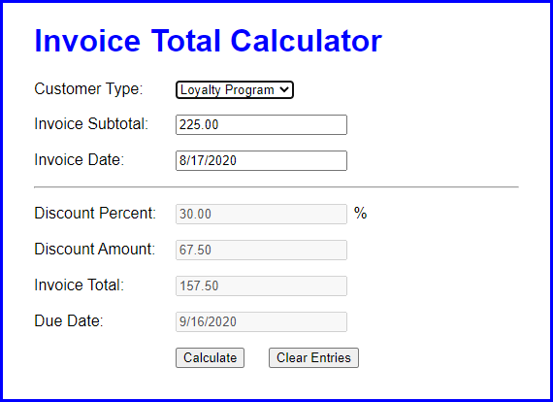

1. Open the application in this folder:

Evaluations\In-Class Tasks\In-Class Task 7\invoice

1. Start the application and click the Calculate button without entering a subtotal or invoice date. An error message will be displayed indicating that the subtotal must be a number greater than zero.
2. Enter a valid subtotal and click the Calculate button again. This time, the discount and invoice total will be calculated, but no invoice date or due date will be displayed.
3. Code a function that formats the Date object that’s passed to it in MM/DD/YYYY format and then returns the date string.
4. Add code to the click() event handler for the Calculate button that gets the invoice date and creates a Date object from it.
5. Add code that checks whether the invoice date is not equal to an empty string and whether the Date object is not a valid date. If so, display an error message, clear the controls, move the focus to the Invoice Date text box, and return.
6. Add an if statement that checks whether the invoice date is equal to an empty string. If so, use the current date as the default date. To do that, you’ll need to get the current date and format it using the function you coded in step 4.
7. Add code that calculates the due date as 30 days after the invoice date. Then, format that date.
8. Add code that sets the values of the Invoice Date and Due Date fields.